[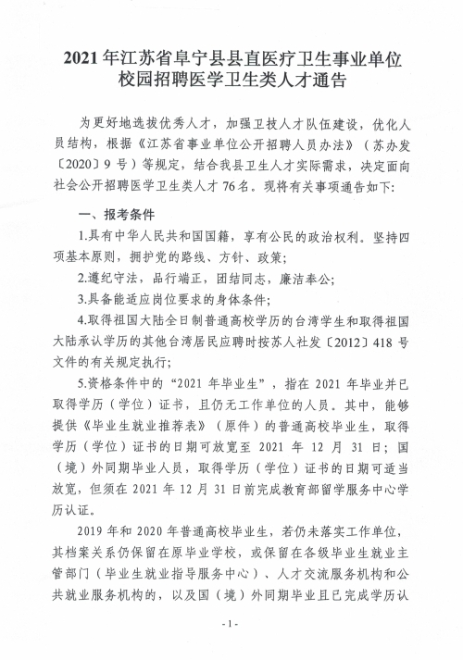](http://funing.yancheng.gov.cn/picture/0/ea05d1f991a644bfa7aea963c8651756.jpg)

[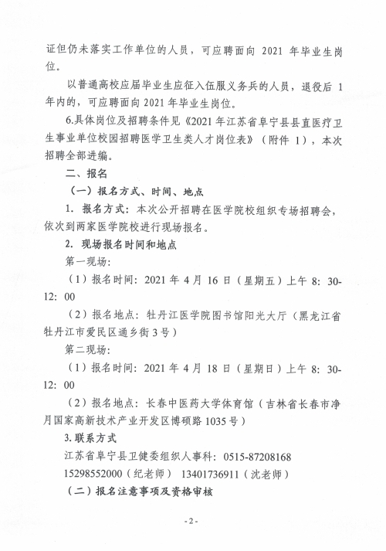](http://funing.yancheng.gov.cn/picture/0/eebf49c697e34d539ba9597add43b7a5.jpg)

[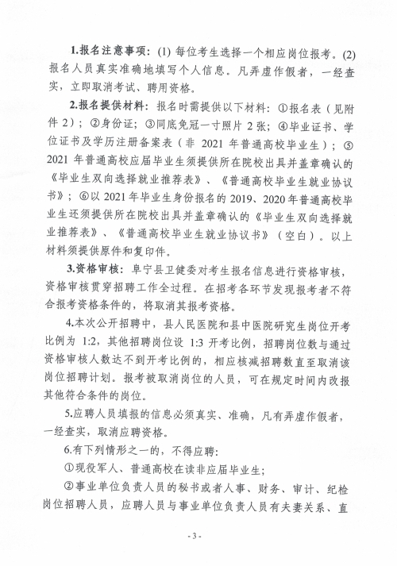](http://funing.yancheng.gov.cn/picture/0/edfb8557cb7048548401bc6a48a91773.jpg)

[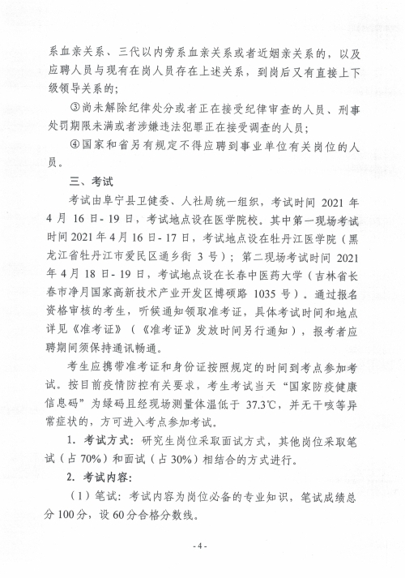](http://funing.yancheng.gov.cn/picture/0/dcca76be93c64e1fae168b91aed8108a.jpg)

[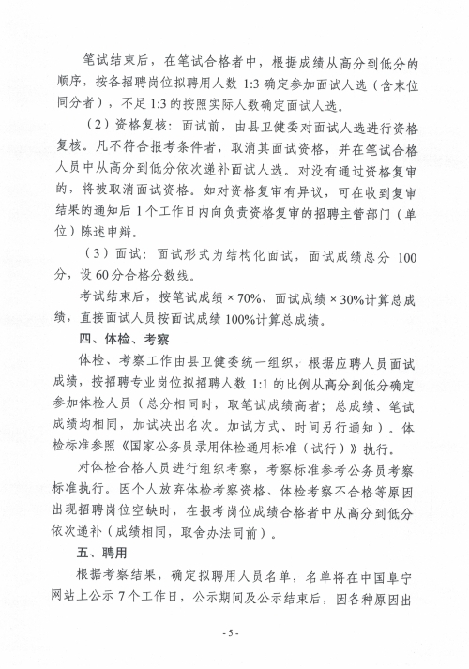](http://funing.yancheng.gov.cn/picture/0/11dbb6032d4c4e3fb0d78353578734a7.jpg)

[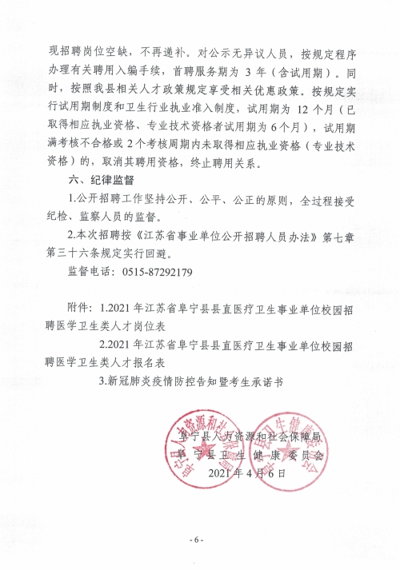](http://funing.yancheng.gov.cn/picture/0/72bad64977fd486094899734507b0387.jpg)